# CareClinic

<https://careclinic.io/medicine-tracker/>

# Context

This project is based on CareClinic, a medicine tracker app.

Tracking all of the medicines you take will help you maintain an accurate representation of your health. This will prove to be useful especially when you are going through a treatment.

If you are taking multiple medications(user can have different medicines) it gets hard to remember(notifications) why you take certain medications. It also gets complicated when you might have multiple medications for multiple different reasons or illnesses(reason for taking the medicine per user). You should be aware of the medication you take and why exactly you take it. Your family members or friends should also be aware of the medication you are taking in case of emergencies (either muiltiple people can connect or just adding a emergency contact).

Terminology

Crud:

# User Stories

**User**

|  |  |  |  |
| --- | --- | --- | --- |
| **As a(n)** | **I want to:** | **So that:** | **MuSCoW** |
| User | Be able to track my medicine(s) | I know if I took them or not | Must |
| User | Be able to login to the application with my (google account- could) | It is easier to login | Must |
| User | Be able to get a reminder when to take my meds | I can remember if I took them | Should |
| User | Be able to CRUD meds in my account | I can have control over my med’s status | Must |
| User | Be able to send a request for someone as my caregiver | I able to control who keeps in track of my personal information | Must |
| User | Be able to accept a request from someone as my caregiver | I able to control who keeps in track of my personal information | Must |
| User | Be able to CRUD notes for each(certain) day(s) and give a personal rating of how the day went | I can use the notes for myself or for my caregivers | Should |
| User | Be able to get a reminder when to refill my meds | I can remember when to ask for more | Should |
| User | Be able to add and remove Caregivers (family or doctor) | I able to control who keeps in track of my personal information | Must |
| User | Be able to give feedback (features/bugs) of the application | I can help the application in efficiency | Could |
| User | Be able to update my personal information | I have control over my personal information | Must |
| User |  |  |  |

**Caregiver**

|  |  |  |  |
| --- | --- | --- | --- |
| **As a(n)** | **Is want to:** | **So that:** | **MuSCoW** |
| Caregiver | See if the user (family member or patient) has taken their meds | I can keep in track of their status | Must |
| Caregiver | For users to login with their google account | It is efficient process | Could |
| Caregiver | Get a reminder if the user has taken their meds after delay time indication | The care giver can inform the user to take their meds | Should |
| Caregiver | Be able to read the meds the user takes | I am aware of what they are taking and the amount | Must |
| Caregiver | Be able to send a request to a user (as family or doctor) as a caregiver | I able to control who I am a caregiver of | Must |
| Caregiver | Be able to accept a request from a user (as family taking the meds) as a caregiver | I able to control who I am a caregiver of | Must |
| Caregiver | Be able to Read the user notes and personal rating | I can overview of how the user is doing while on the meds | Should |
| Caregiver | Be able to get a reminder when the user needs to refill their meds | I can remind them/ know of their status | Should |
| Caregiver | Be able to add and remove users (taking meds) | I able to control who I am a caregiver of | Must |
| Caregiver | Be able to give feedback (features/bugs) of the application | I can help the application in efficiency | Could |
| Caregiver | Be able to update my personal information | I have control over my personal information | Must |

**Developer(maintainer of the project) (maybe)**

|  |  |  |  |
| --- | --- | --- | --- |
| **As a(n)** | **I want to:** | **So that:** | **MuSCoW** |
| Developer |  |  |  |
| Developer |  |  |  |
| Developer |  |  |  |
| Developer |  |  |  |
| Developer |  |  |  |
| Developer |  |  |  |
| Developer |  |  |  |

**System**

|  |  |  |  |
| --- | --- | --- | --- |
| **As a(n)** | **Is able to:** | **So that:** | **MuSCoW** |
| System | Track one or multiple medicines per user | A user is able keep in track of taking their medicine | Must |
| System | For users to login with their google account | It is efficient process | Could |
| System | Give the user and caregiver a reminder (if indicated) to take their meds | So that the user and caregiver are aware of the meds status | Should |
| System |  |  |  |
| System |  |  |  |

* A user can login with an email and pass (google account opt.)
* a user can register one or many different medications.
* A user can indicate the purpose of the medicine, the amount of the medicine,
* A user can register it’s date of birth, name, emergency contact, doctor’s name
* A user is able to track their medicine improvement by adding personal feedback, side effects and a rating per day.
* Medication can be taken anytime of the day
* Medication has an amount taken per day
* Medication can be taken on certain day
* Medication should be taken while consuming food or on an empty stomach (opt.)
* Medication has an expire date (opt.)
* System reminds you when to refill your medicine, when to take your medicine (opt.)
* System reminds user which medicine will/is expired (opt.)
* System informs the user what to do if they miss to take their medicine (opt.)
* System show case rating in a graph to taking the medicine with feedback for each point. (opt.)
* Caregiver is able to see what medicine the user is taken
* Caregiver is NOT able to add medication to the user
* Caregiver is NOT able indicate if the user has taken their meds
* Caregiver is given a reminder for (certain) meds if not taken by the user after a delay
* Caregiver is able

# Not in scope

**not included: (can be added for the future)**

* Fitness to tracking the medicine
* Nutrients consumed
* CareTeam Reminders – Alerts Caregiver if you have problems

# Here are the top benefits of using the CareClinic App:

* Add as many medicine and Supplements as needed
* Get notified if there are interactions* or synergies
* Add Therapy, Activity, Nutrition that will aid in your health goal
* Quickly set reminders for any of the above modalities
* Integrate with any wearables if needed
* Mark your reminders as “Taken” or “Skip” them as needed
* Get periodic reminders for refills, and or from your [careteam](https://careclinic.io/care-team/" \o "careteam)
* Log any one-time-medications (PRN’s) as needed
* View reports and correlations by yourself or share them with your care provider.

# Non-functional requirements

* Accessibility
  + web application
  + To use for users with medication
* Backup
  + Details of the user medication and intake
* Maintainability
  + The ease with which a software system or component can be modified to correct faults, improve performance or other attributes, or adapt to a changed environment
* Extensibility
  + To be able to append additional element and features to its existing structure
* Privacy
  + Personal information is secured and not easily accessible without the correct authorization
* Reliability
  + The consistency of performs according to its specifications.
* Security
  + Users can’t access other users’ information
  + Personal information is stored securely
* Testability
  + To be able to show/prove the quality of the application

**Individual project case: Kwetter**

Author: Nico Kuijpers

Date: November 21, 2019

Kwetter is a social platform with main purpose to exchange text-based messages of at most 140 characters. Below, the functionality is described for the profile page and the start page.

**Profile page:**

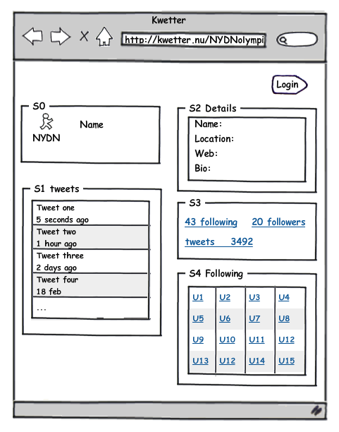

|  |  |  |
| --- | --- | --- |
| Function | Description |  |
| Profile picture profile name | Profile picture and name of the user |  |
| Profile details | User details: bio, location, website  Bio is limited to 160 characters |  |
| Own tweets | 10 most recent tweets by this user |  |
| Followers | Other users following this user.  By clicking followers in S3, a list of followers appears in S1 |  |
| Following | Other users followed by this user.  After clicking one of the links in S4, information of that user wil appear in S4 |  |
| Heart | Users can add a heart symbol to the tweet of another user. A user can give at most one heart symbol to each tweet. | Optioneel |

**Start page:**

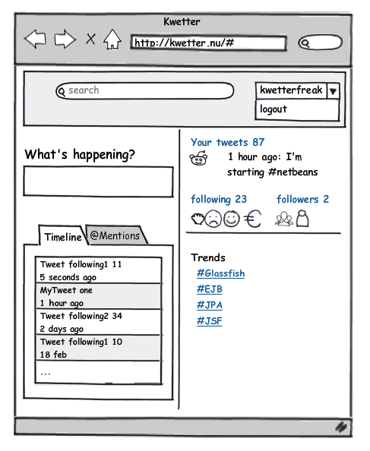

This personalized page appears after logging in.

|  |  |  |
| --- | --- | --- |
| Function | Description |  |
| Search | Search within all tweets. Results will be shown in the timeline tab. |  |
| What’s happening? | Textbox to enter your tweet with a maximum of 140 characters. The tweet will be shown immediately under 'Your tweets'. |  |
| Timeline | Timeline of tweets from the user and from other users being followed. |  |
| @Mentions | Tweets mentioning the user appear in this tab. It is possible to mention another user by adding @username in the tweet. |  |
| Following/ followers | After clicking on either the following or followers link, the profile page appears. |  |
| Trends | Clicking on one of the trends results in list of tweets in the timeline tab. These tweets are at most one week old and contain a hashtag followed by the selected trend. |  |
| Logout | After clicking logout the profile page appears. It is then possible to login as a different user. |  |
| Login | After clicking login and providing credentials, the starting page appears filled with tweets and other information for the user that is logged in. |  |

Registration:

Create a registration form for new users.

Moderation:

Create a page for users with the role of moderator. Moderators can see a list of users and their roles. They can remove users who spread insulting tweets or use swear words. In addition, moderators can change the role of other users to moderator.

Administration:

An administrator can add or remove accounts of other users and may change the roles of other users.